Check for understanding |  |  |  |  |  |  |  |  | 
Checking for understanding (CfU) is a constant process critical for successful learning. It requires responsiveness from the teacher throughout a lesson and whilst there needs to be agility to respond as needs arise, checks for understanding are also deliberately planned for. It is the ‘check it’ part of our learning framework.

Lemov states that the champions of CfU make a habit of small intentional habits, applied consistently and result in a trusty safety net for pupils’ learning. The use of CfUs is critical in explicit teaching as they allow pupils and teachers to determine levels of understanding.

CfU in Oak lessons are designed to be snappy interactive moments where the teacher can check understanding after explanations have been delivered and they assess the key learning points from the explanation. They are designed to support teachers to adapt the lesson based on pupil responses. CfU should be carefully selected to reflect the common misconceptions and mistakes in the content being taught. Being able to create CfUs that explicitly address misconceptions is reliant on the teacher having a detailed knowledge of their subject and how learning progresses.

General
- The misconception is explicitly addressed during explanation and checked via a CfU and assessment exit quiz.

- Answers generated from CfUs should be short and easy to respond to on a mini whiteboard.

✔ Example  This CfU is quick for pupils to respond to on a mini-whiteboard and the use of 1. and 2. supports structure to the pupils’ response.  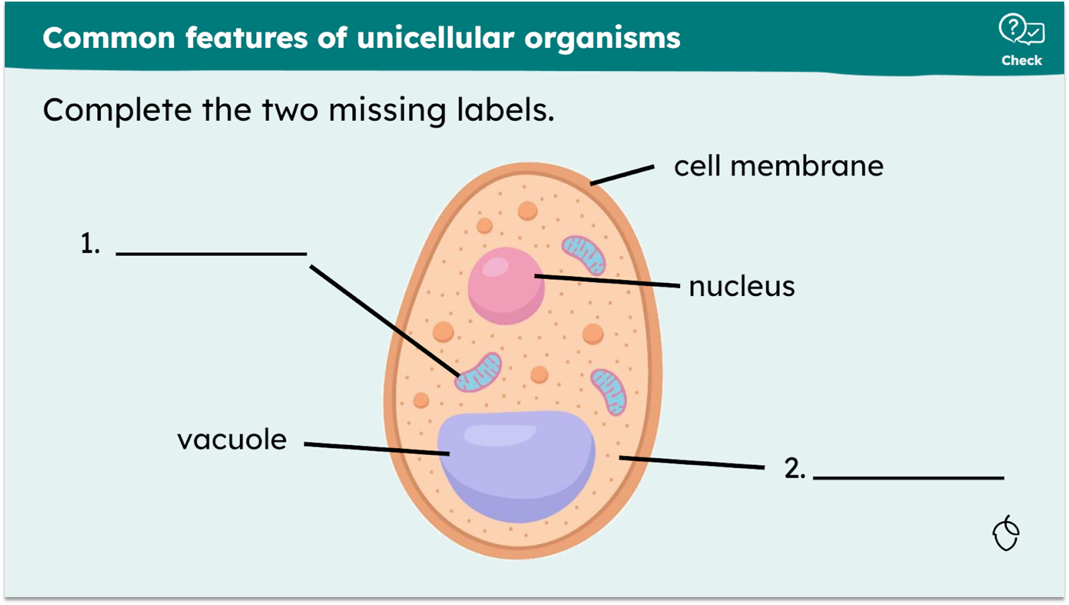  KS3 science |  |  |  |  |  | ✘ Non-example  This CfU would not lead to a quick response from pupils and a teacher could not scan the room and complete a quick assessment of learning.  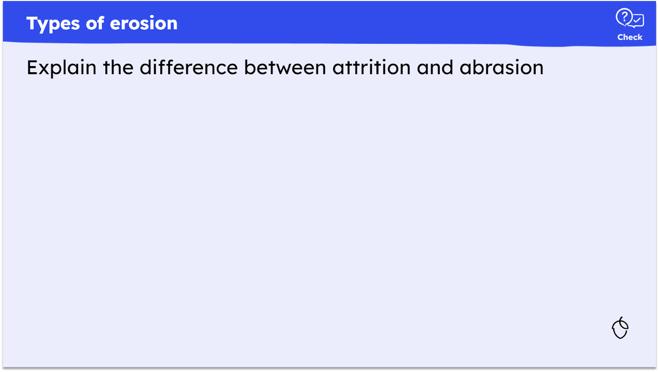  Oak created
- There is a minimum of two CfUs per learning cycle.

- Slides will switch between explanation and CfUs intermittently, rather than all explanation slides followed by all CfU slides. CfU questions are therefore directly linked to, and peppered throughout, explanations.

In the example below of a learning cycle, the CfUs are peppered thoughtfully throughout the explanation.

✔ Example
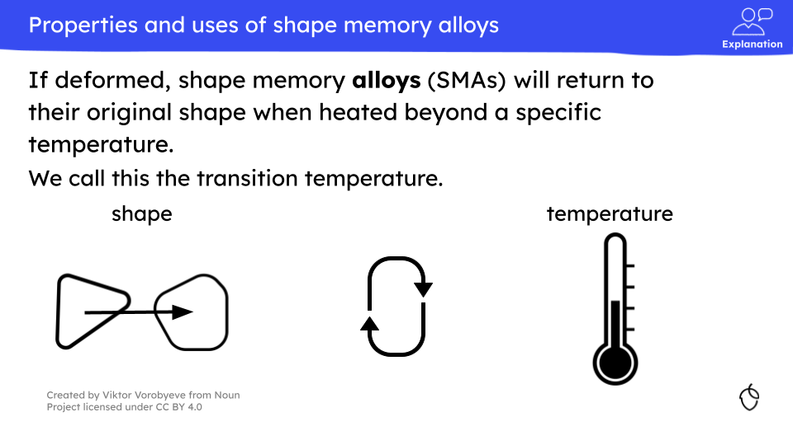   |  |  |  | 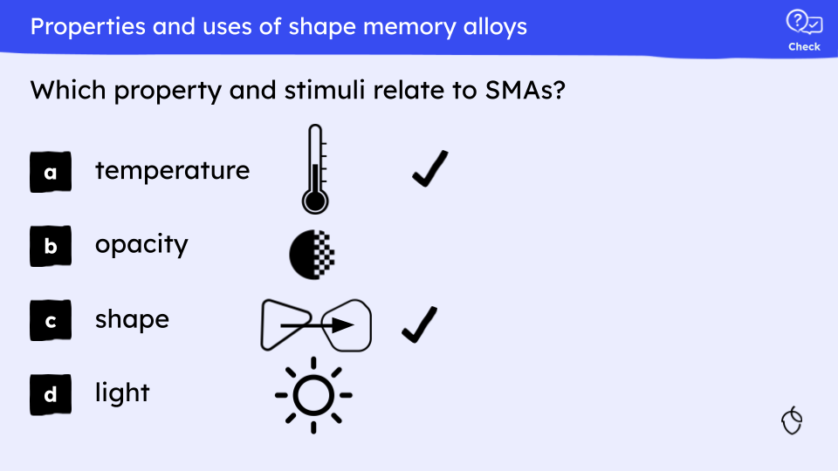   |  |  |  | 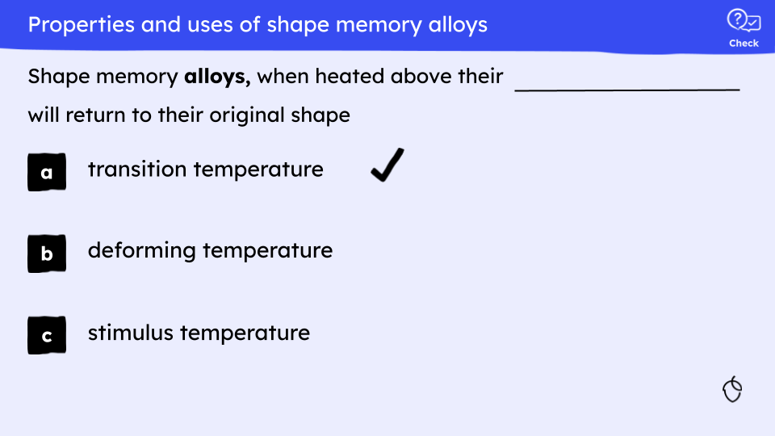  
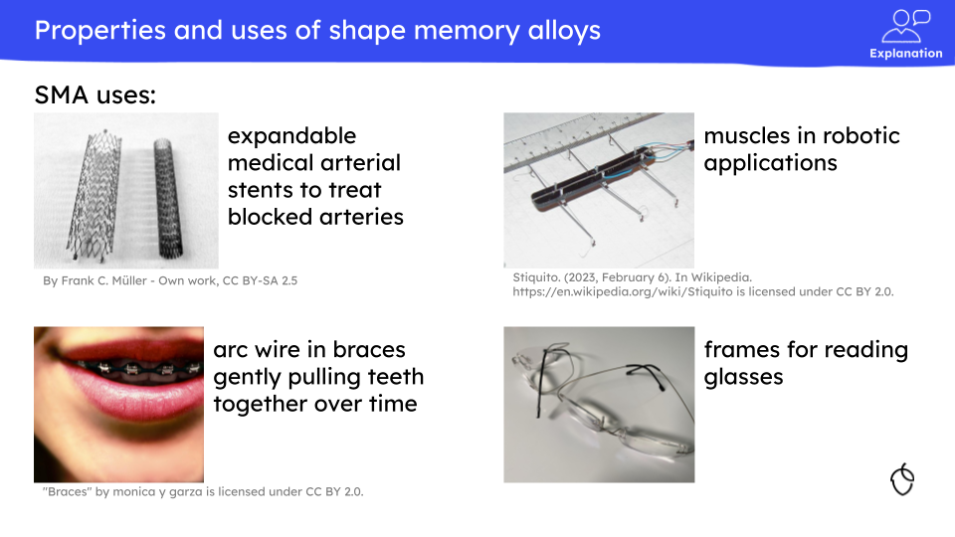   |  |  |  | 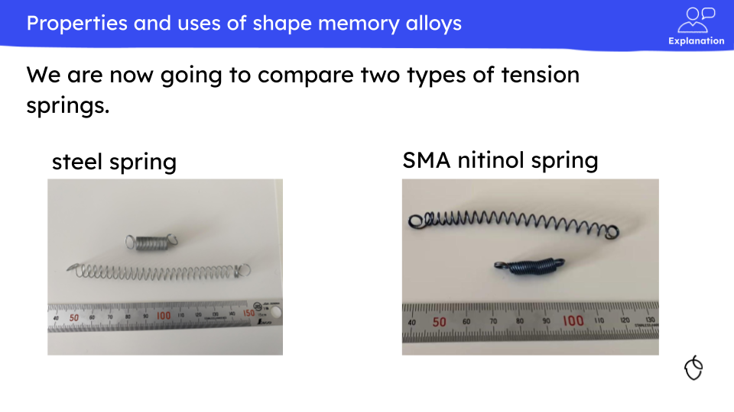   |  |  |  | 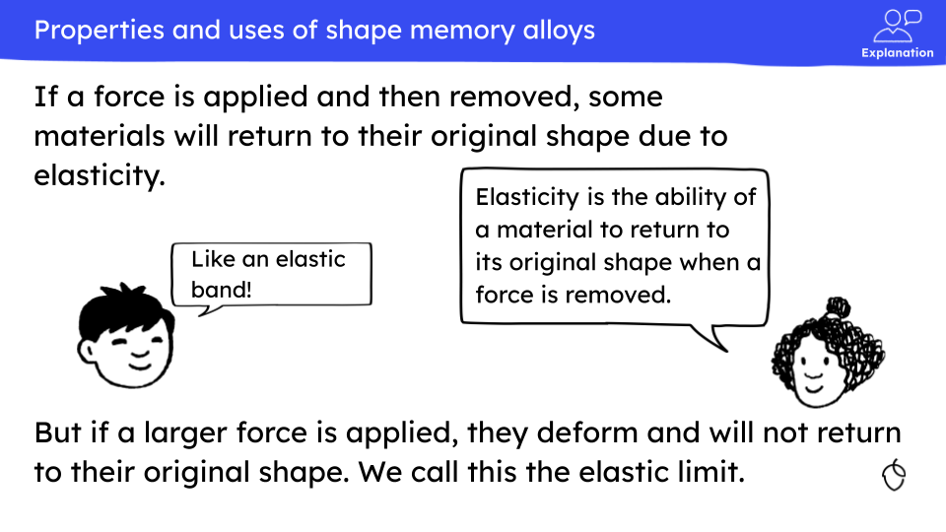  
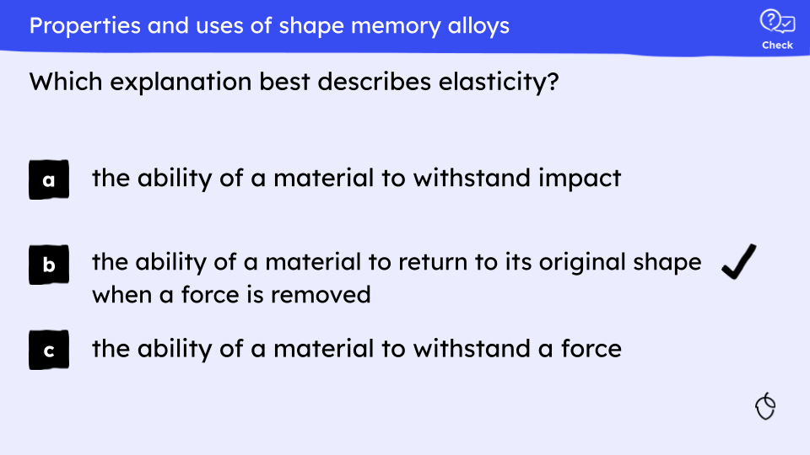   |  |  |  | 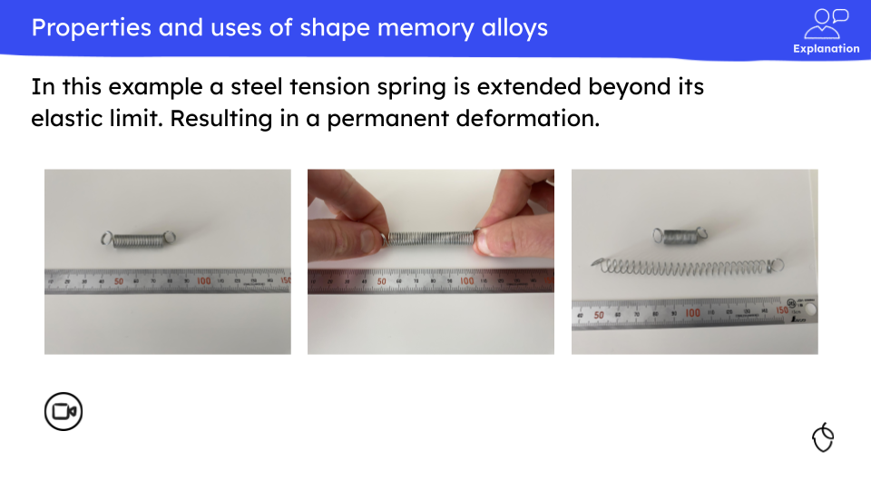   |  |  |  | 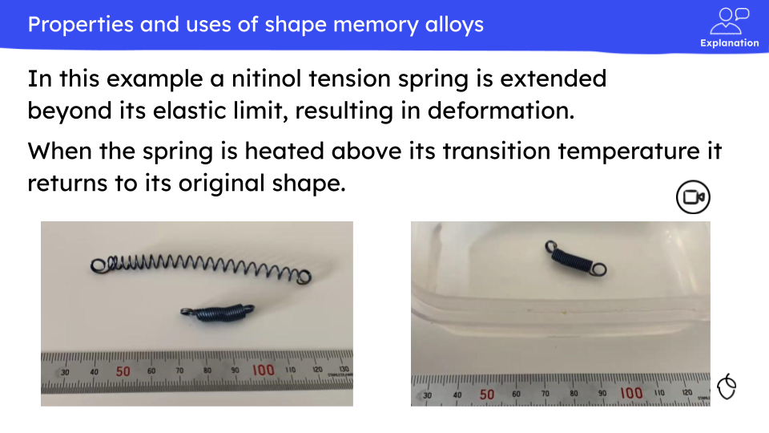  
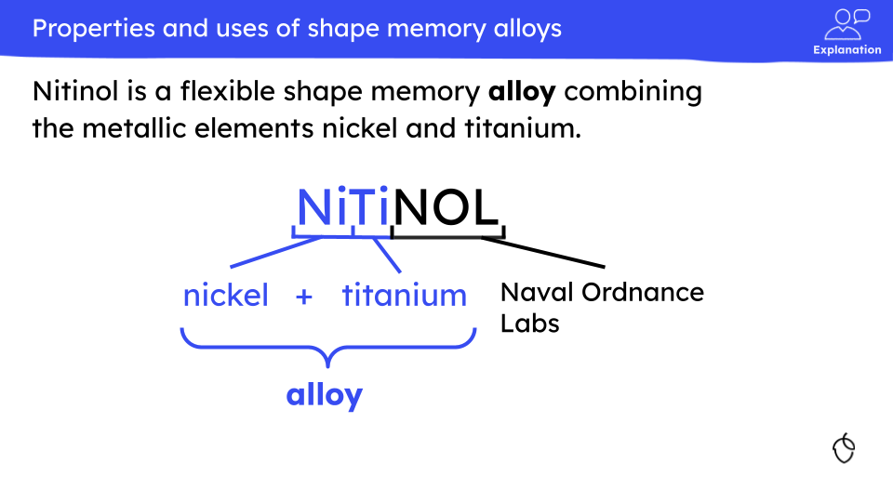   |  |  |  | 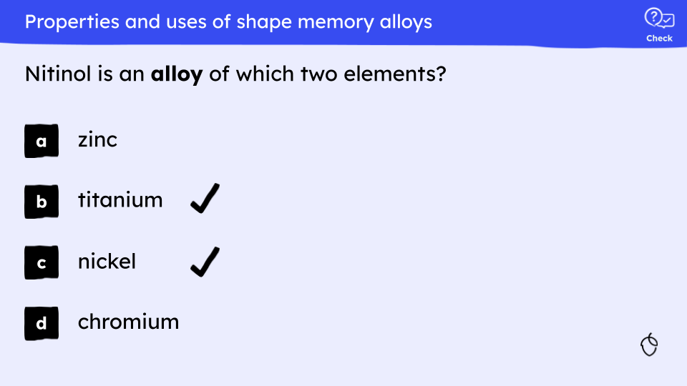
- Within a learning cycle, CfUs are aligned with the explanation and key learning points.

- It is not possible to guess the correct answer as CfUs are pitched accurately and link directly to the explanation explicitly covered prior.

- CfU questions will ideally be focused to expose common mistakes or misconceptions.

- Where CfU questions following an explanation have different levels of demand, lower demand questions are asked first and demand increases through the set.

- In examples where the word in a question is required for emphasis, the use of bold can be used, but the word should be in the banner colour.
✔ Examples  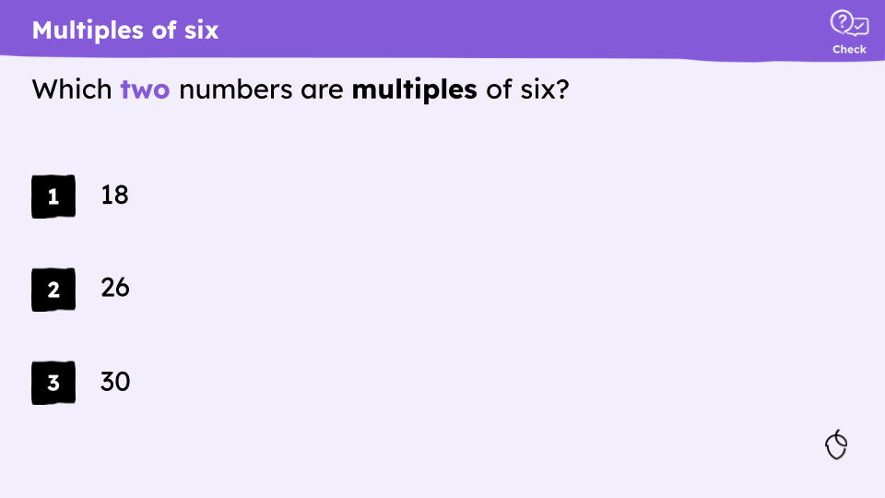  The word ‘multiple’ is a keyword and in black bold. The word two is in banner colour bold to emphasise pupils need to choose two answers |  |  |  |  |  | 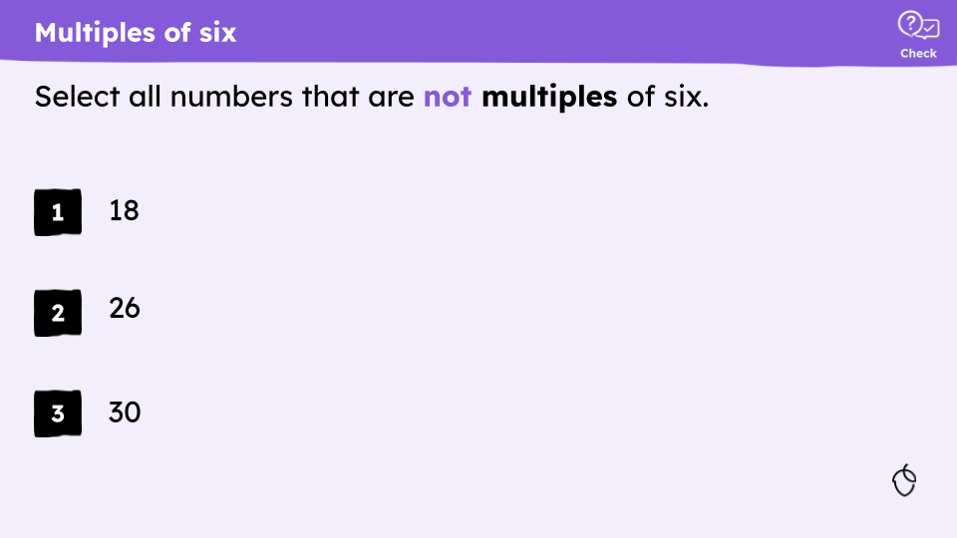  The word ‘multiple’ is a keyword and in black bold. The word not is in banner colour bold to emphasise to pupils that the answer is not a multiple of six.
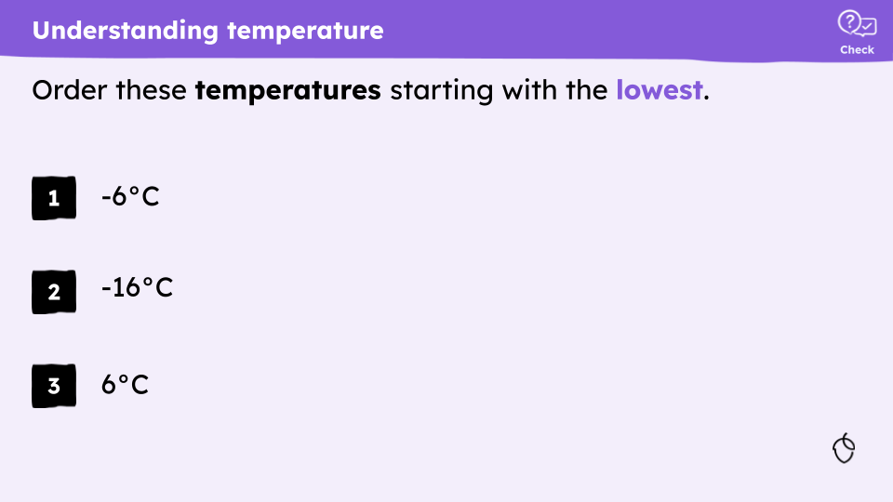
The word ‘temperature’ is a keyword and in black bold. The word lowest is in banner colour bold to signal to the pupils the answer should start with the lowest.

Question type

- There are three types of questions that can be used as CfUs: multiple choice, short answer and true/false/why.

1. Multiple choice |  |  | 2. Short answer |  |  |  |  |  | 3. True/false/why
- CfU question type should vary between learning cycles to avoid task fatigue.

1. Multiple choice

Multiple choice questions work especially well as the teacher can easily see the responses a/b/c at a glance. They consist of a question stem, one or two correct responses and at least two distractors. They are especially useful when:

- the answer is one from a defined set e.g. planets
- the desired level of challenge is low*
- misconceptions can be directly addressed through distractors
- where nuance in understanding leads to minimally different distractors

*this does not mean that all MCQ questions are low challenge, merely that recalling knowledge can be less challenging when answer options are presented.

- Will include 3 - 5 answer choices.

- Answer options should be minimally different from each other.

- CfU multiple choice question answers should be labelled as a,b,c rather than 1,2,3. Templates are provided in the slide deck.

✔ Example  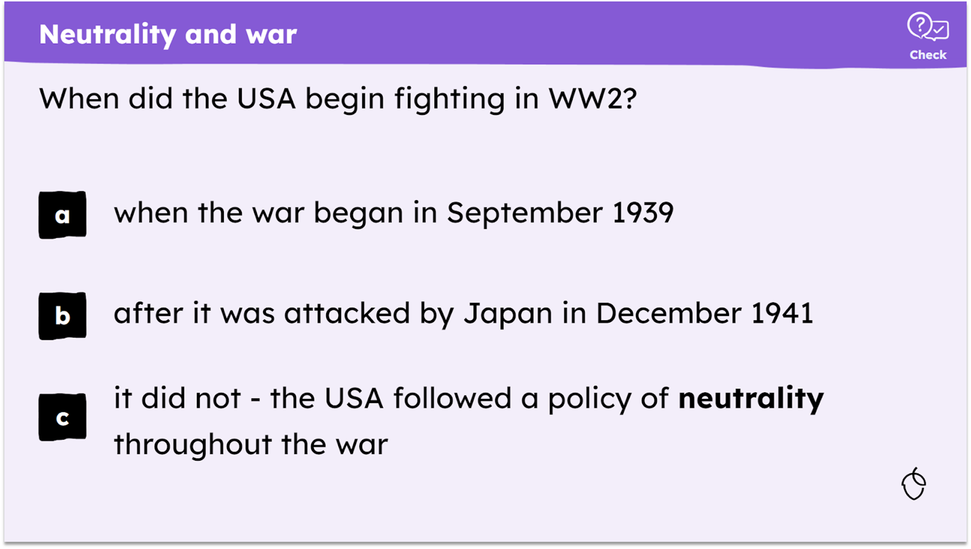  KS3 history |  |  |  |  |  | ✘ Non-example  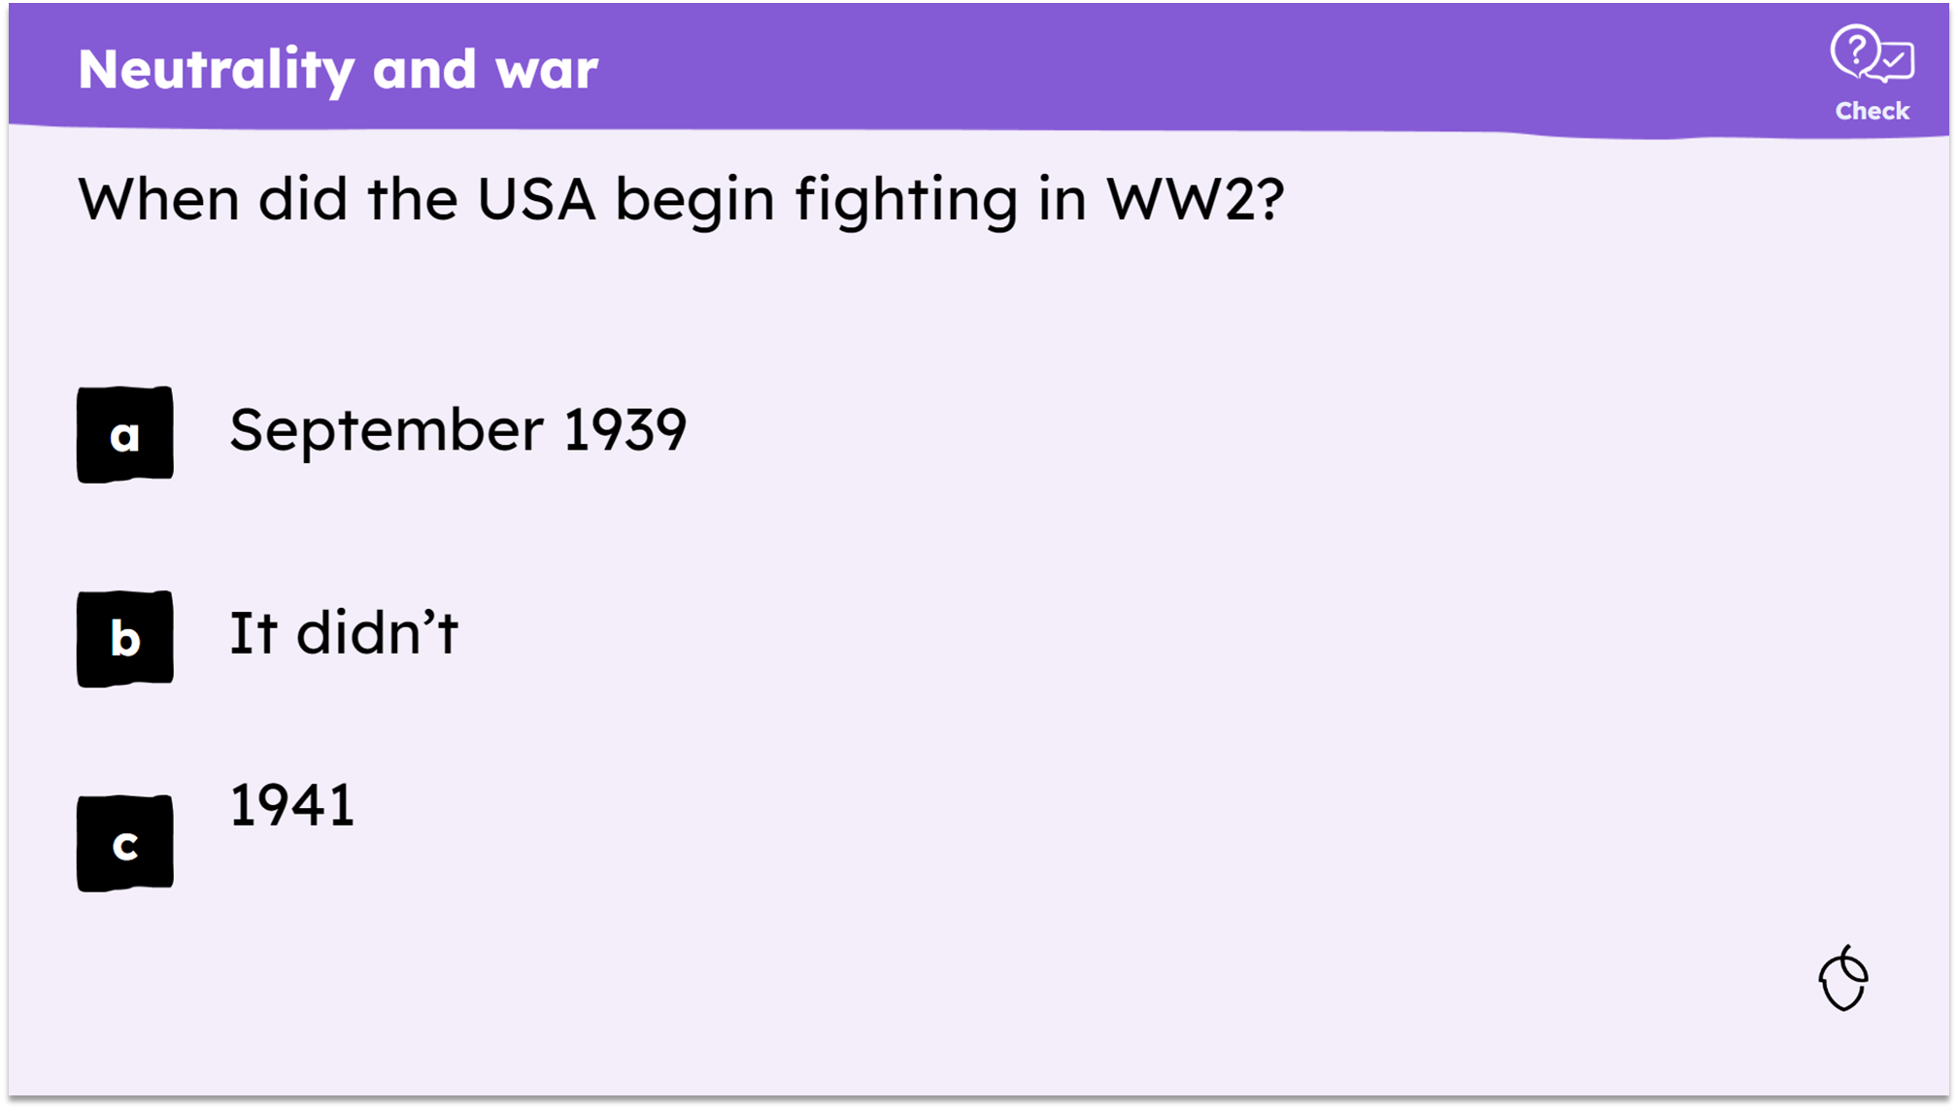  Oak created
further examples in The Library (available September 2024)

2. Short answer

Short answer questions consist of a gap fill or a question that requires a single word or number as an answer. Short answers are best used in the following scenarios:

- when there aren’t enough plausible distractors
- spelling of the correct answer is important
- multiple-choice alternatives might introduce or reinforce a misconception
- the desired level of challenge is high

- In gap fill activities in slide decks, indicate missing words with a 4pt drawn black line which is removed when answers are revealed. When using more than one line on a slide, they should be the same length to avoid giving clues about word length.

✔ Example    KS3 science |  |  |  |  |  | ✘ Non-example  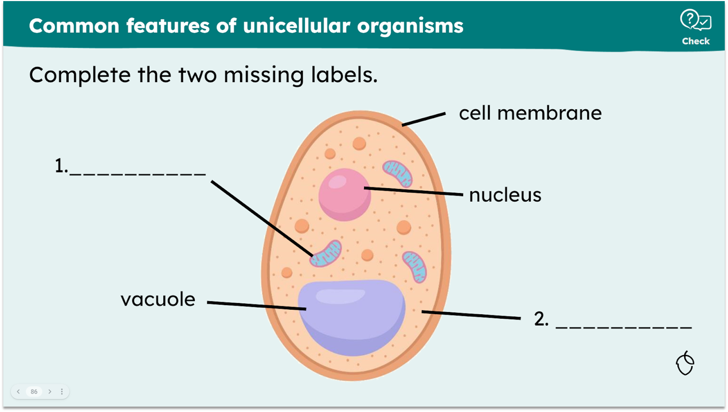  Oak created
further examples in The Library (available September 2024)

3. True/false/why

True/false is a straightforward way of checking understanding of a simple factual piece of knowledge. However, there is a 50:50 chance of guessing the correct answer so ensuring pupils’ are encouraged to explain their answer when the answer is incorrect provides evidence of understanding. True/false/why questions are best used when:

- there is a simple fact to check
- checking of explanation detailed in the learning cycle is important

✔ Example  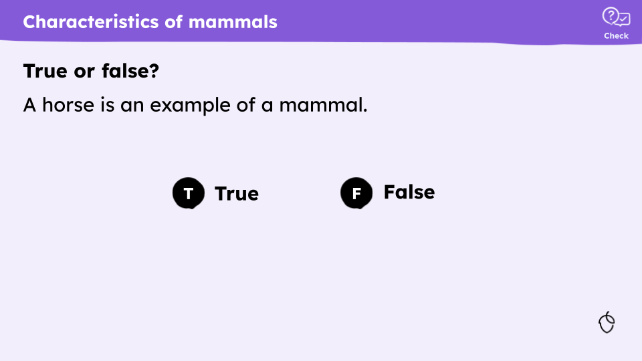  Oak created  This example is checking a simple factual statement. The answer is true and the preceding explanation detailed the characteristics of mammals. |  |  |  |  |  | ✘ Non-example  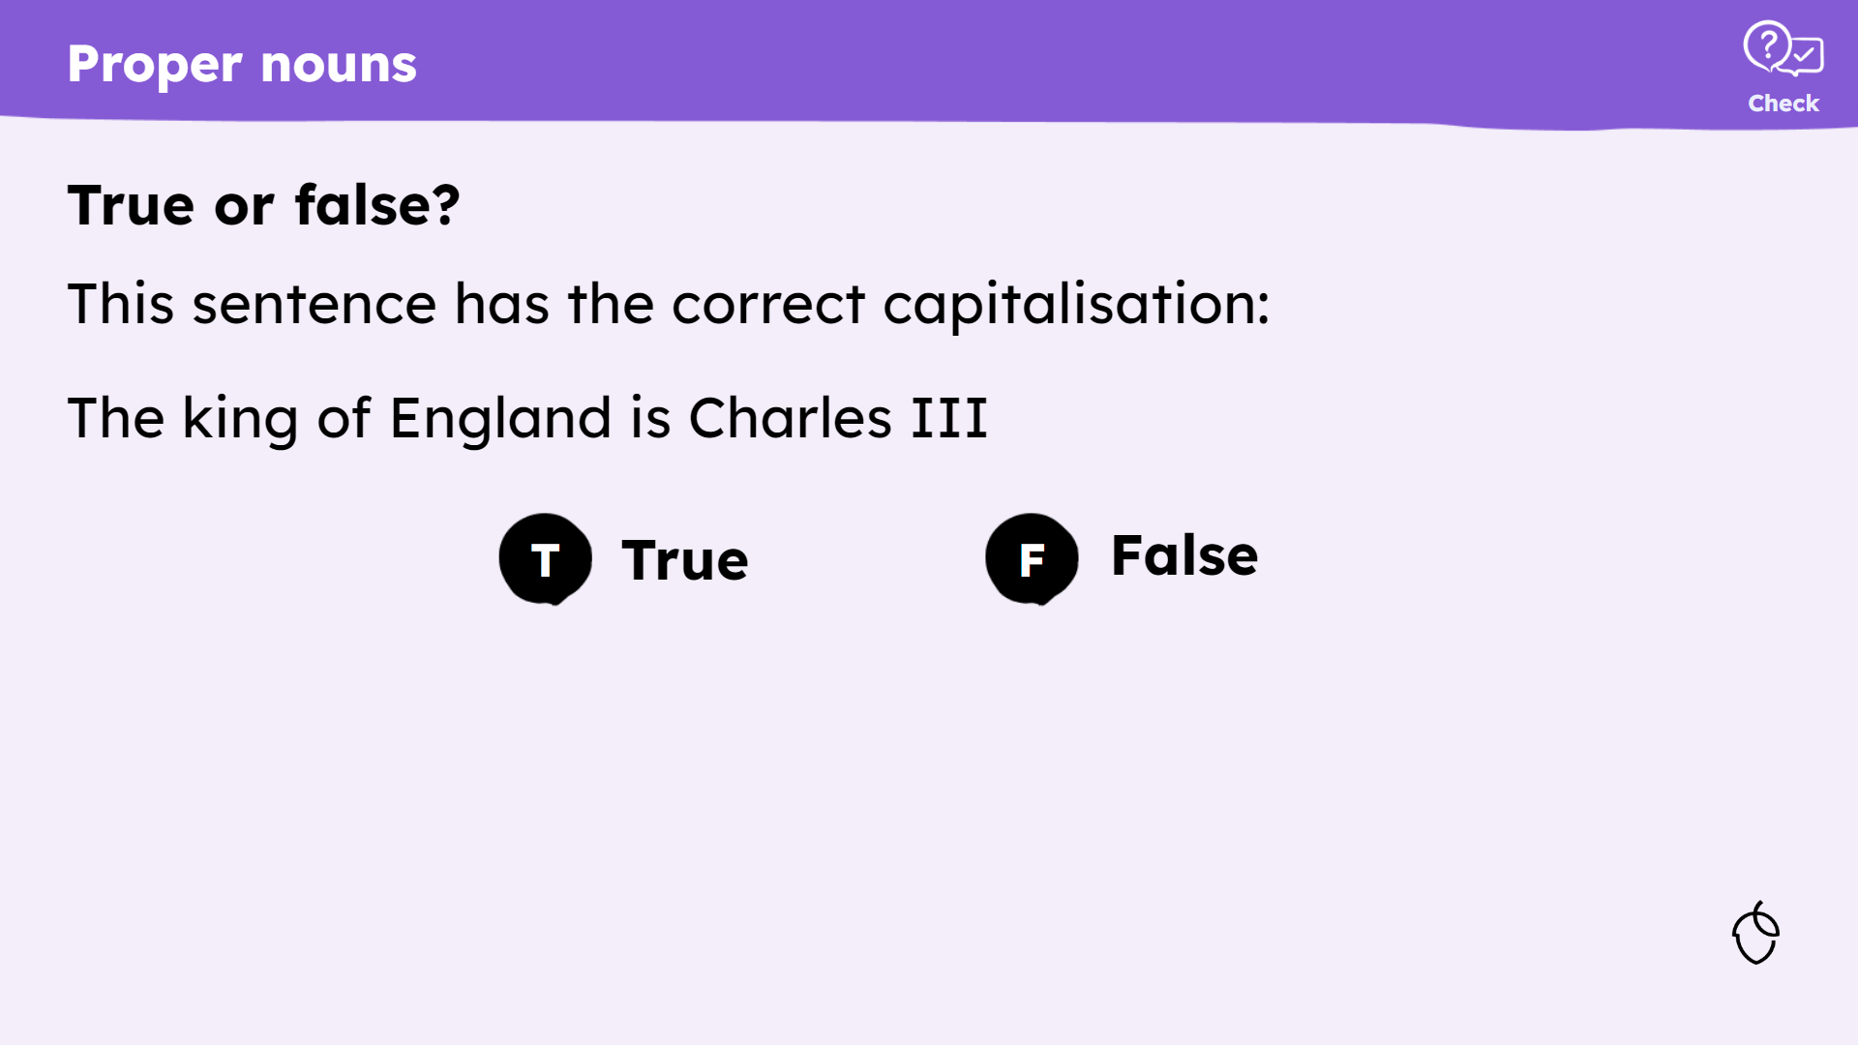  Oak created  The initial statement in this non-example is too complex leading to a complicated explanation which extends the time taken to feedback on this CfU.
further examples in The Library (available September 2024)

Feedback

Feedback will be provided for all CfUs. The approach will vary accordingly but should provide pupils with the answer. Where appropriate feedback should give information to explain the answer.

- When there may not be a correct answer to a check for understanding, a model response is provided with the acknowledgement that there may be other valid responses

- Answers in the slide deck are animated so no additional answer slides are needed for CfUs.

- Answers in the slide deck should include full working where appropriate. For calculations, feedback might be a worked calculation.

Question type
Multiple choice

- For multiple choice questions, an animated tick indicates the correct answer(s).

✔ Example  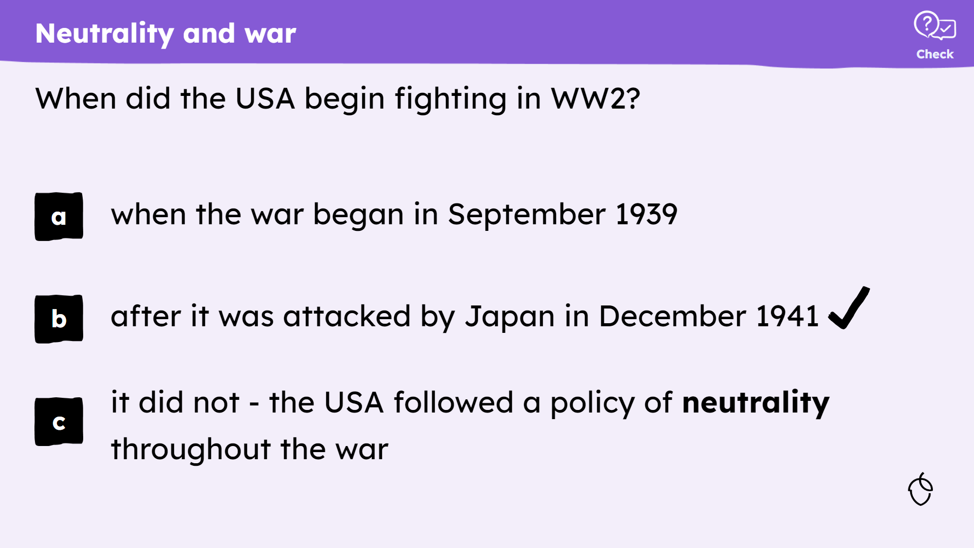  KS3 history |  |  |  |  |  | ✘ Non-example  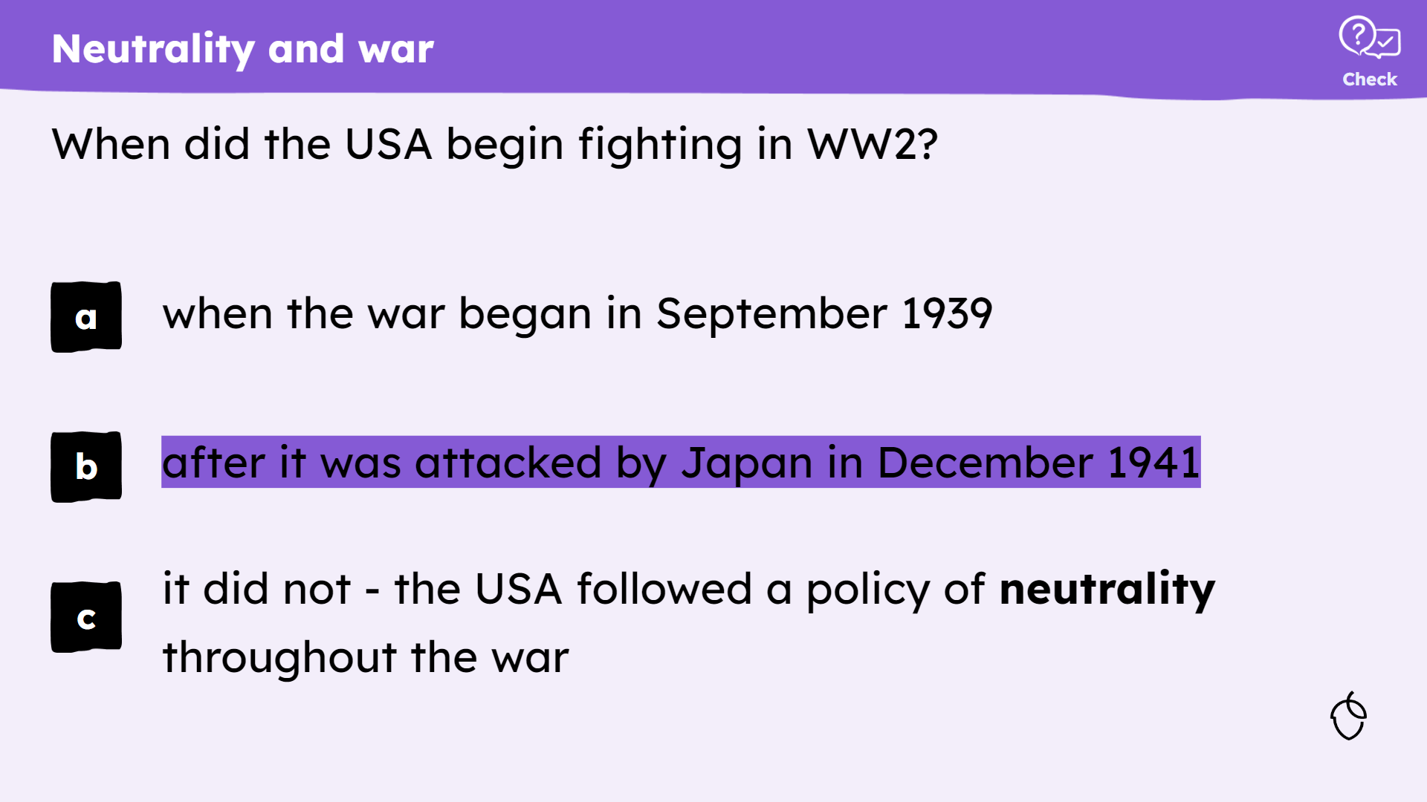  Oak created
Short answer

- For short answer questions, the response is animated and written in Kalam font.

✔ Example  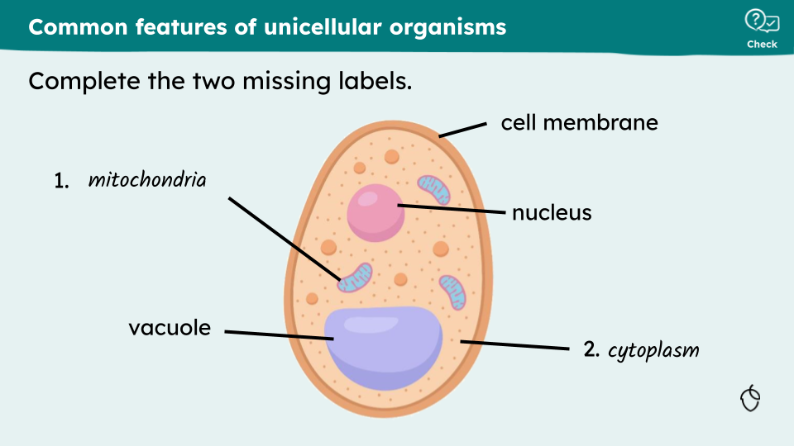  KS3 science |  |  |  |  |  | ✘ Non-example  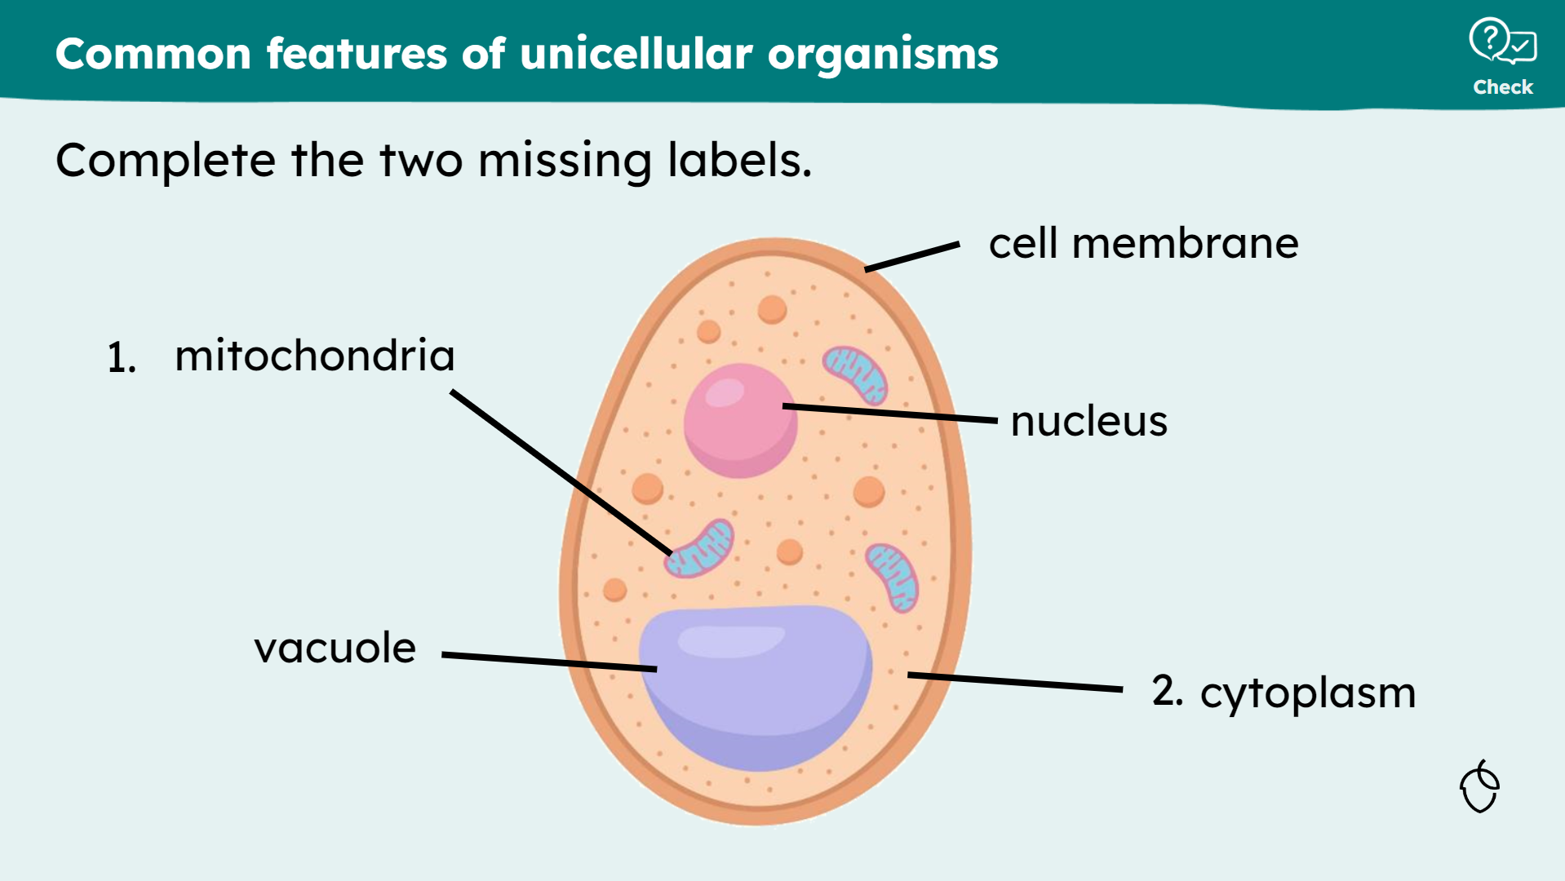  Oak created
True/false/why?  Response  - An animated tick and ‘Why?’ appear simultaneously. The template does not include ‘Why?’ as this is not always appropriate.  - A second click reveals a full sentence of explanation in Kalam font.  - The explanatory sentence should include the initial statement where possible to explain the answer where this feels appropriate. |  |  |  | ✔ Example  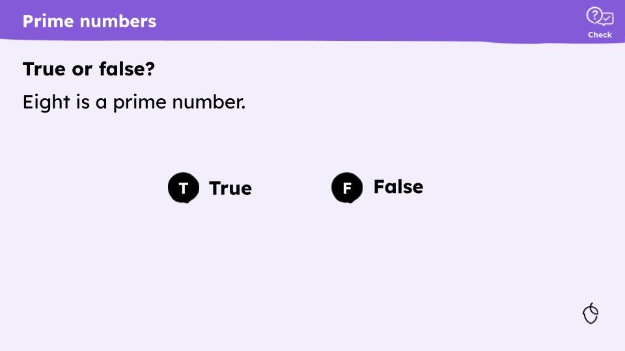    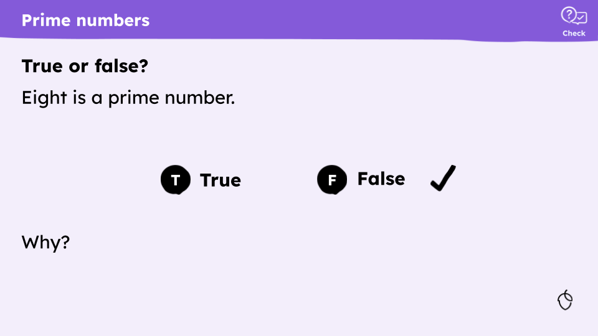    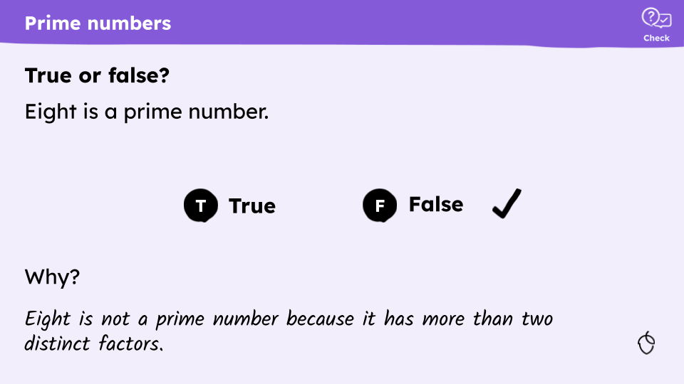  Oak created |  |  |  | ✘ Non-example  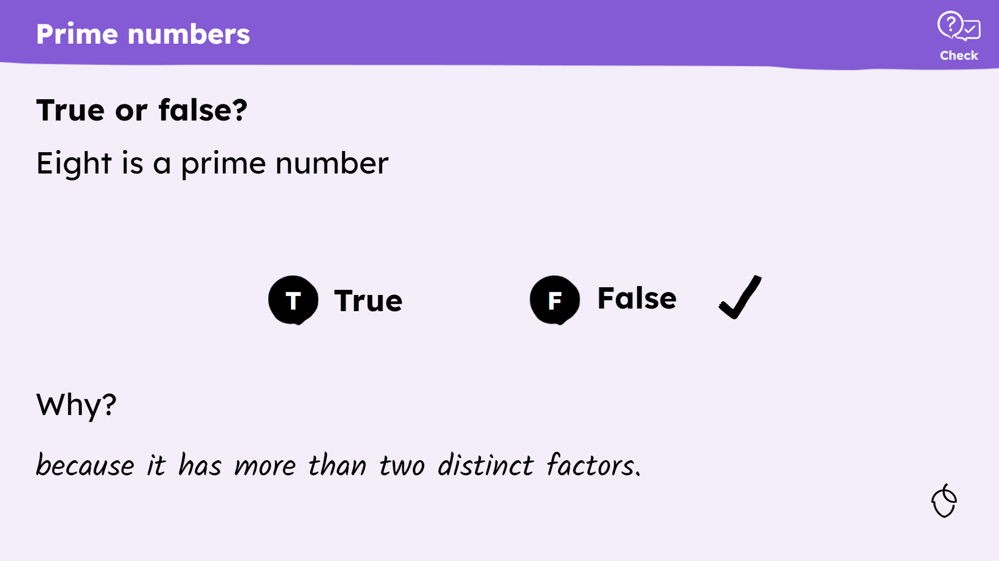  Oak created  This non-example is not animated and the explanatory sentence does not include the initial statement. This does not model a good standard of written communication.

